Physics Day 1
Physics:

Branches of Physics:
1.
a.

2.

Unit Conversions and the Factor-Label Method

Distance vs Displacement
Distance:

Displacement:

Scalar quantity:

Vector quantity:

Wall Ball Bounce
Draw set-up:

Trial 1: Distance =
Displacement =
Trial 2: Distance =
Displacement =
Trial 3: Distance =
Displacement =

Displacement Practice
positive to the right and negative to the left
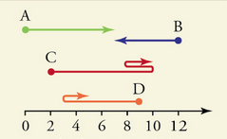

Distance travelled for A =
Displacement of A =
Distance travelled for B =
Displacement of B =
Distance travelled for C =
Displacement of C =
Distance travelled for D =
Displacement of D =

2D Wind – up Toy
Trace the path of the toy from a starting point. Measure distance and displacement.
Half a wind N and half a wind W: Distance =
Displacement =
Half a wind NW: Distance =
Displacement =
Full wind E and full wind S: Distance =
Displacement =
For 2D displacements we can use x and y vectors or compass vectors.
Vector addition:

Draw vectors to scale on grid paper. Then you can measure the magnitude of the displacement with a ruler and the direction with a protractor.

Do the Vector Walk!

