Elementary Students: Tell us what you think.

How old are you? ____________ What grade are you in? ______________

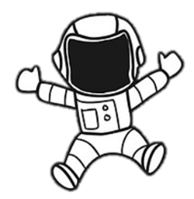
Circle the things you did here? Science Public Speaking Cooking

What was your favorite? Science Public Speaking Cooking

What was your least favorite? Science Public Speaking Cooking

What do you like most about the library? _____________________________

_________________________________________________________________

If you were in charge of this program, what would you keep the same?

If you were in charge of this program, what would you change?

What subjects would you like to do at the library?

Write a sentence about this program.

