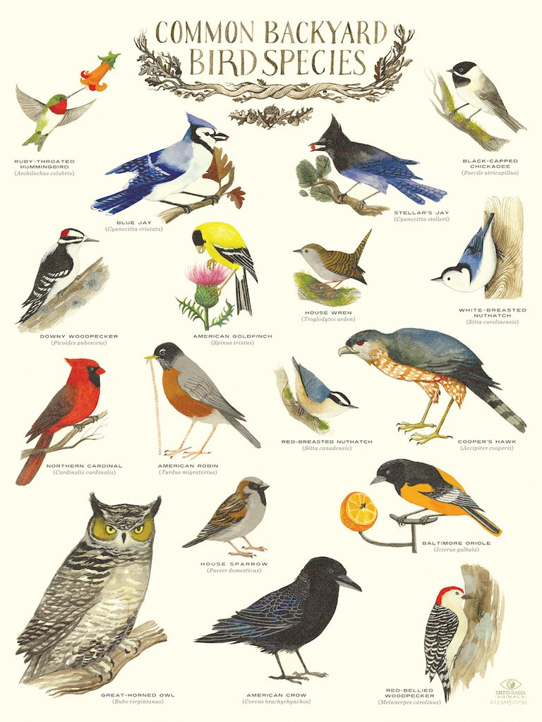
https://inforamaart.com/products/common-backyard-bird-species-infographic-poster-by-diana-sudyka

