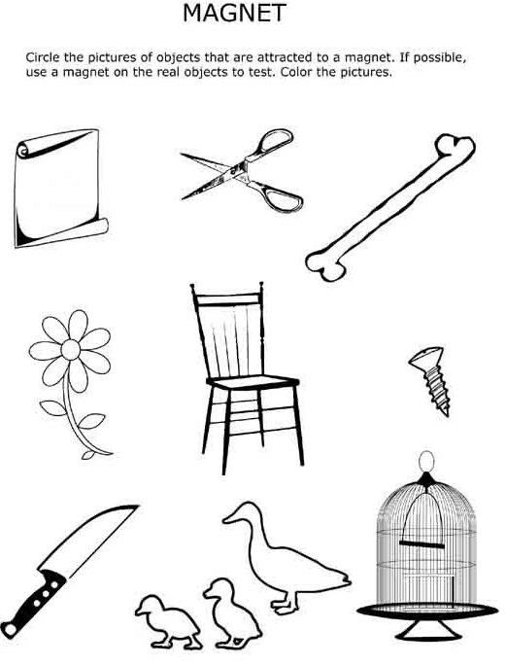
Name:_____________________ Date:________ Name:_____________________ Date:________

